Predict 411

Predictive Modeling II

Section 56

Winter Quarter

******************************************************************************

School of Continuing Studies

Northwestern University

******************************************************************************

Daniel Prusinski

In compliance for Master of Science Predictive Analytics

Bachelor of Science Business Marketing

******************************************************************************

Program Analyst

Wooddale Church

6630 Shady Oak Road

Eden Prairie, MN 55344

**Executive Summary**

In the current economic climate, keeping total cost down is a matter of survival for any competitive airline industry. Through the initial exploratory data analysis (EDA), it was found that the variable Revenue Passenger Miles has the strongest correlation with total cost and is statistically significant. Through data transformations, the natural log was used to make the data user-friendly; as a result when interpreting the coefficients, please perceive the values accordingly. The variable Load Factor suffers from heteroscedasticity, and given its overall contribution to the model, I would recommend dropping it from the model. While the initial EDA was helpful in establishing a strong predictor variable, I would recommend a further analysis including time and a delineation between the airlines in the EDA.

**Introduction**

In 1978, the US government deregulated the airline industry and as a result over $60 billion dollars has been lost to-date through airlines filing for bankruptcy (Npr.org & Severin Borenstein). For the deregulated airline industry the game is quite simple, cover your total costs or cease to exist in your business model. In order for an airline to stay profitable, it must understand the dynamics between its total cost (dependent variable) with revenue, price of fuel, and capacity utilization (independent variables). At first glance, one would expect the relationship between the independent variables and the dependent variable to be positive. The pie chart to the left was created by Charles Najda, from the Department of Economics at Stanford University, and visually breaks down airline operating costs. Fuel only represents 13 percent of operating costs and capacity utilization does not encompass operating costs, thus I suspect neither of these will have a strong correlative relationship with total cost. For this report, revenue is expressed as follows: Revenue Passenger Miles, and can be understood as the more miles a passenger accumulates the greater the total cost for the airline. Revenue passenger miles as a variable encompasses all the operational expenses of an airline and I suspect it will have a strong correlative relationship with total cost. A further analysis of these dynamics will aid airline executives in better understanding its bottom line and how to remain profitable.

**Analysis**

In order to meet the objective of exploring the relationship between the dependent variable and independent variables, an exploratory data analysis must be conducted . I will be utilizing the EDA paradigm and structure put forth by Bruce Ratner found in his book *Statistical and Machine-Learning Data Mining*:

Problem/Objective: Explore the relationship between Total Cost (Y), and the independent variables Revenue Passenger Miles (Q), Price of Fuel (PF), and Capacity Utilization for load factor (LF).

Data: The data has been aggregated and has been supplied from management.

Analysis: Scatter plots and correlation coefficients will be used to study the nature of the relationships between the independent variables and their relation to the dependent variable.

Model: After assessing the data, a model will be used. Management has recommended using a regression model, but the standard OLS assumptions will need to be validated.

Results/Interpretation: Once the model has been validated and iterations complete, a recommendation will be written to management in regard to the relational dynamics amongst the variables listed above.

A properly executed EDA for management must reflect that the data was the driving force behind constructing the model. The steps outlined above are ordered such that the data drives which model is used, and the analyst’s personal bias is mitigated.

**Data**

Following the outline above, exploring the data is the next step for the EDA. There are a total of 90 observations with 0 missing values in the data set for each variable. The response variable along with two of the independent variables requires a data transformation in order to better study the variables. Each variable has its own descriptive breakdown explained in a subsection below.

Capacity Utilization (LF): This variable did not require a data transformation and represents the utilization of overall capacity for the airplane load factor.

| **Descriptive Stats for Variable: Capacity Utilization as LF** | | | | | | | |
| --- | --- | --- | --- | --- | --- | --- | --- |
| **N** | **Miss** | **Minimum** | **Maximum** | **Median** | **Mean** | **Variance** | **Std Dev** |
| 90 | 0 | 0.432 | 0.676 | 0.566 | 0.560 | 0.003 | 0.053 |

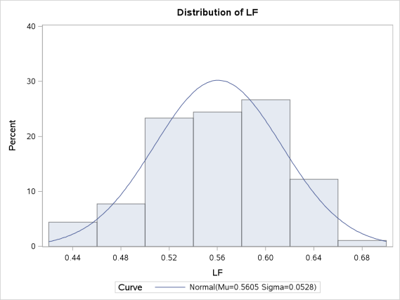LF is the easiest variable to understand given that the minimum and maximum values are less than one and the difference is .244. In addition, the mean and median are relatively close to one another which would lead me to believe there is a small standard deviation (SD). The variance is small, of which the SD is based. The visual demonstration, via the histogram to the right, reveals exactly what would be expected from the table above. This variable is slightly negatively skewed, but overall is an excellent variable to conduct analysis.

Revenue Passenger Miles (Q and LogQ): Variables often need transformation in order to be better understood and presented in a form that is conducive to iterative analysis. In this analysis, variable Q needed a log transformation.

| **Descriptive Stats for Variable: Log_Q and Q** | | | | | | | | | |
| --- | --- | --- | --- | --- | --- | --- | --- | --- | --- |
| **Variable** | **Label** | **N** | **Miss** | **Minimum** | **Maximum** | **Median** | **Mean** | **Variance** | **Std Dev** |
| log_q Q | Q | 90 90 | 0 0 | -3.279 0.038 | 0.661 1.936 | -1.187 0.305 | -1.174 0.545 | 1.324 0.285 | 1.151 0.534 |

At first glance, this variable might appear to not need a transformation based on the descriptive statistics, the min, max, variance and SD all look fine. The red flag that caught my eye was the difference between the median and mean, which suggests that the observations are not normally distributed. After the log transformation, the mean and median are much closer.

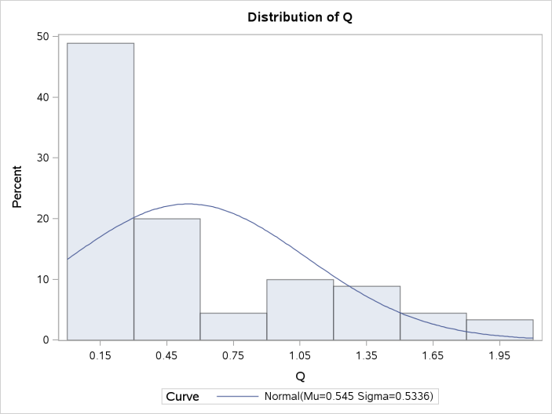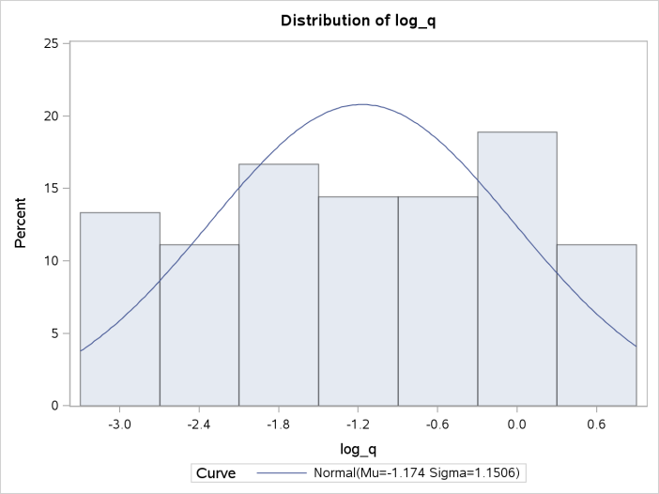

The histogram reveals the severely skewed variable Q, which is why visual statistics are an important asset to EDA. After the log transformation, variable Q follows a normal distribution with only a slight negative skew of -.1.

Price of Fuel (PF and LogPF): Similar to variable Q, variable PF needed a log transformation.

| **Descriptive Stats for Variable: Log PF and PF** | | | | | | | | | |
| --- | --- | --- | --- | --- | --- | --- | --- | --- | --- |
| **Variable** | **Label** | **N** | **Miss** | **Minimum** | **Maximum** | **Median** | **Mean** | **Variance** | **Std Dev** |
| log_pf PF | PF | 90 90 | 0 0 | 11.550 103795.000 | 13.831 1015610.000 | 12.787 357433.500 | 12.770 471683.011 | 0.660 108572166191 | 0.812 329502.908 |

In its original form, variable PF is very hard to understand. Grasping the variance and (SD) is rather trivial given the sheer size of the numbers. In addition, one should note the difference between mean and median. After the log transformation, the variable becomes more focused and is easily understood. The min and max are not far apart. The median and mode would lead me to believe there is a relatively normal distribution, and the variance/SD fits the variable.

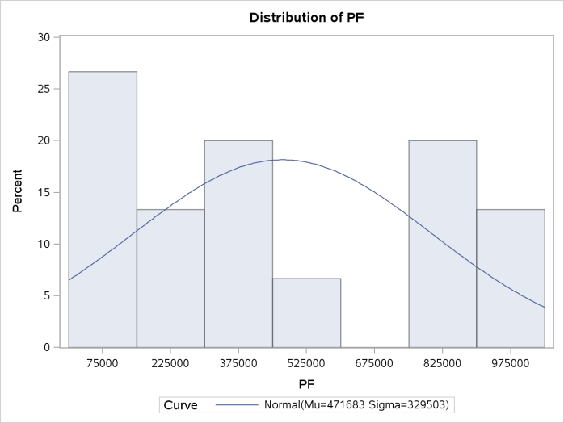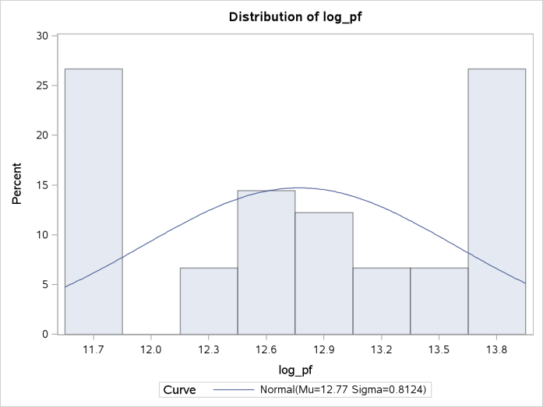

Variable PF in its original form is positively skewed .40, and appears to not follow a normal distribution. After the log transformation, the skew is only -.14, and the distribution allows one to conduct further analysis.

Total Cost (C and LogC expressed as y): This variable represents the dependent variable, and is expressed in millions of dollars.

| **Variable** | **Label** | **N** | **Miss** | **Minimum** | **Maximum** | **Median** | **Mean** | **Variance** | **Std Dev** |
| --- | --- | --- | --- | --- | --- | --- | --- | --- | --- |
| y C | C | 90 90 | 0 0 | 11.142 68978.000 | 15.373 4748320.000 | 13.365 637001.000 | 13.366 1122523.833 | 1.281 1.4210421E12 | 1.132 1192074.704 |

Variable C is very similar to variable PF in that its large numbers are hard to understand. In addition, the large difference between median and mean suggest that a log transformation is necessary. After the log transformation, expressed as y, the numbers are perceivable and the median and mean fall close to one another.

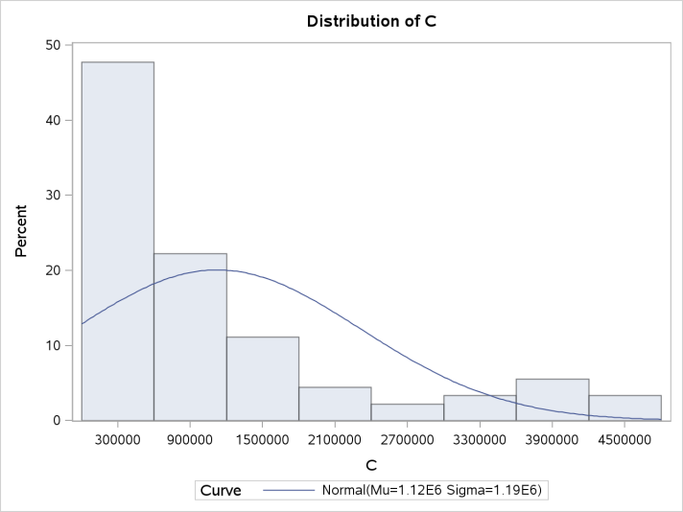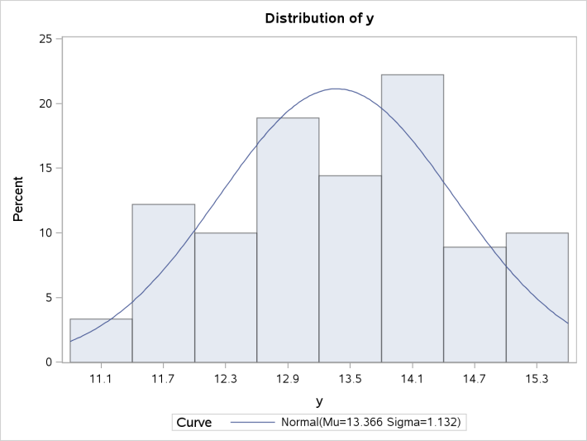

Before the log transformation, C has a massive positive skew of 1.53 and would be a difficult variable to analyze. After the log transformation, the skew is only -.10 and the variable is easier to understand.

The data has been analyzed in its original form and transformed for better analysis. Utilizing the log transformation makes it easier to work with the variables, but after building the regression model the log transformation will have to be taken into account when interpreting the coefficients (Applied Econometrics, Ajmani).

**Results**

From the data analysis, management has encouraged using an Ordinary Least Squares (OLS) regression model. Through using this model, the following analysis will be conducted: correlation, assessment of collinearity, interpretation of key metrics and the regression coefficients, validation of OLS assumptions.

The correlation analysis reveals Log Q has a strong correlative relationship with the predictor variable. Log PF and LF do not have strong correlative relationships with y, but between each other they have a stronger correlative relationship of .59. This discovery will require further study in the analysis. Preliminarily, the model has a strong R-squared but the Adj R-squared is preferred given that the model has more than one variable. The F-value is very significant based on three degrees of freedom. This can be interpreted as at least one variable is explanative of the dependent variable in the model.

| **Pearson Correlation Coefficients, N = 90** | | | | |
| --- | --- | --- | --- | --- |
|  | **y** | **log_q** | **log_pf** | **LF** |
| **y** | 1.00000 | 0.95350 <.0001 | 0.53966 <.0001 | 0.56753 <.0001 |
| **log_q** | 0.95350 <.0001 | 1.00000 | 0.28900 0.0057 | 0.49967 <.0001 |
| **log_pf** | 0.53966 <.0001 | 0.28900 0.0057 | 1.00000 | 0.59881 <.0001 |
| **LF** | 0.56753 <.0001 | 0.49967 <.0001 | 0.59881 <.0001 | 1.00000 |

| **Analysis of Variance** | | | | | | |
| --- | --- | --- | --- | --- | --- | --- |
| **Source** | **DF** | **Sum of Squares** | | **Mean Square** | **F Value** | **Pr > F** |
| **Model** | 3 | 112.70545 | | 37.56848 | 2419.34 | <.0001 |
| **Error** | 86 | 1.33544 | | 0.01553 |  |  |
| **Total** | 89 | 114.04089 | |  |  |  |
| **Root MSE** | 0.12461 | | **R-Square** | | 0.9883 |
| **Dependent Mean** | 13.36561 | | **Adj R-Sq** | | 0.9879 |
| **Coeff Var** | 0.93234 | |  | |  |

Statistically the variables are significant, and Log Q has the largest r-squared. The variance inflation factors (VIFs) do not warrant concern for multi-collinearity. If any of the VIFs had been above 6 for any variable, the model would need to be adjusted for the effects of collinearity. Interpreting the coefficients are key for understanding how the model will predict. Variable LF did not require a log transformation, but the response variable did require a log transformation. Thus, the coefficient for LF can be interpreted as a one unit change in LF equals a (-1.62751 * 100%) change for dependent variable y holding all other things constant. Variables Log_Q and Log_PF fall into the log-log scenario. Their interpretation is: a 1% change in Log-Q,PF equals a .883% and .454% change in the response variable. The overall model has strong predictive qualities and is statistically significant, but in order to use this model the OLS assumptions need to be validated.

| **Parameter Estimates** | | | | | | |
| --- | --- | --- | --- | --- | --- | --- |
| **Variable** | **DF** | **Parameter Estimate** | **Standard Error** | **t Value** | **Pr > |t|** | **Variance Inflation** |
| **Intercept** | 1 | 9.51692 | 0.22924 | 41.51 | <.0001 | 0 |
| **log_q** | 1 | 0.88274 | 0.01325 | 66.60 | <.0001 | 1.33304 |
| **log_pf** | 1 | 0.45398 | 0.02030 | 22.36 | <.0001 | 1.55936 |
| **LF** | 1 | -1.62751 | 0.34530 | -4.71 | <.0001 | 1.90468 |

At this point in the EDA, checking the models diagnostics is done to validate the OLS assumptions for further assessment of the model adequacy. In the books *Econometric Analysis* by William Greene, *Regression Analysis by Example* by Chatterjee and Hadi and *Applied Econometrics* by Vivek Ajmani, five assumptions are identified that form the backbone for validating OLS regression. Satisfying the linearity assumption is initially assessed from the correlation analysis, but further validated with individual scatter plots.

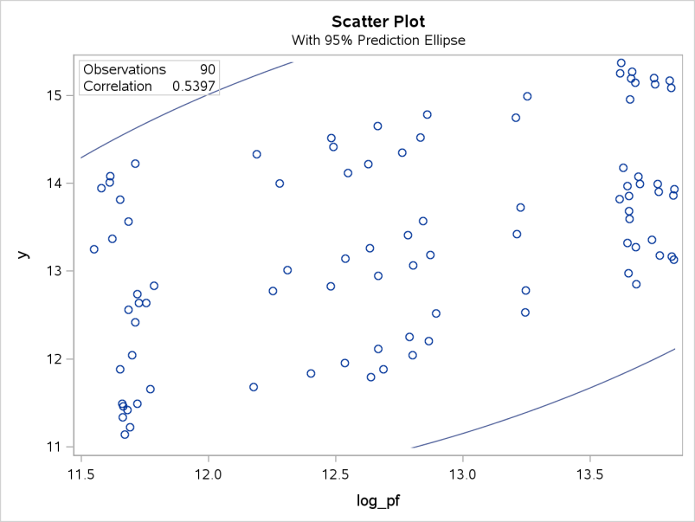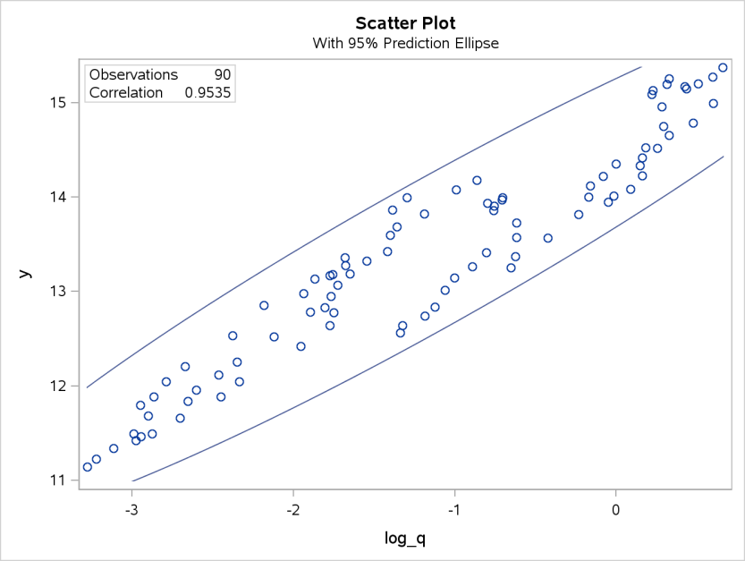Log Q, revenue passenger air miles, has a linear relationship with y, total cost. The scatter plot is also helpful for seeing patterns other than linearity. For example, notice the arrows. The points demonstrate a miniature upward trend, which might pertain to specific airlines in this data set. I note this pattern, and want to make this a point to mention for further studying.

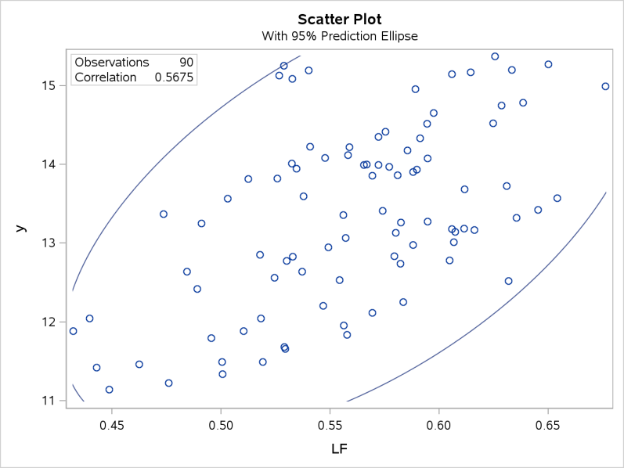 Variable Log_PF is linear, but notice the three tiers of linearity. I drew the three lines to show the pattern. In my last section of the report, I would follow up with further research into what these minor trends mean.

Variable LF is also linear, and does not have any visually discernible patterns. After reviewing both the correlation analysis and scatter plots, it can be concluded that the linearity assumption has been satisfied. From visually assessing the scatter plots of Log_Q and Log_PF, patterns were found in the scatter plot that would warrant follow up investigation to understanding the micro-trends in the data.

Multicollinearity occurs when independent variables have a strong linear relationship with each other (statisticssolutions.com). The problem that results from a model suffering from multicollinearity is coefficients that are not precise, high standard errors and changing coefficients when certain variables enter or leave the model. Signals of collinearity include high correlation values between independent variable, VIFs greater than six, and drastic shifts in coefficients when variables are added or dropped.

| **Parameter Estimates** | | | | | | |
| --- | --- | --- | --- | --- | --- | --- |
| **Variable** | **DF** | **Parameter Estimate** | **Standard Error** | **t Value** | **Pr > |t|** | **Variance Inflation** |
| **Intercept** | 1 | 9.51692 | 0.22924 | 41.51 | <.0001 | 0 |
| **log_q** | 1 | 0.88274 | 0.01325 | 66.60 | <.0001 | 1.33304 |
| **log_pf** | 1 | 0.45398 | 0.02030 | 22.36 | <.0001 | 1.55936 |
| **LF** | 1 | -1.62751 | 0.34530 | -4.71 | <.0001 | 1.90468 |

| **Pearson Correlation Coefficients, N = 90** | | | | |
| --- | --- | --- | --- | --- |
|  | **y** | **log_q** | **log_pf** | **LF** |
| **y** | 1.00000 | 0.95350 <.0001 | 0.53966 <.0001 | 0.56753 <.0001 |
| **log_q** | 0.95350 <.0001 | 1.00000 | 0.28900 0.0057 | 0.49967 <.0001 |
| **log_pf** | 0.53966 <.0001 | 0.28900 0.0057 | 1.00000 | 0.59881 <.0001 |
| **LF** | 0.56753 <.0001 | 0.49967 <.0001 | 0.59881 <.0001 | 1.00000 |

From looking at the correlation analysis, log_pf and LF prompted an initial concern of potential collinearity. But, after analyzing the parameter estimates it can clearly be seen that the VIFs are well below any concern for multicollinearity. Verifying that the model does not suffer from multicollinearity satisfies the Full Rank assumption.

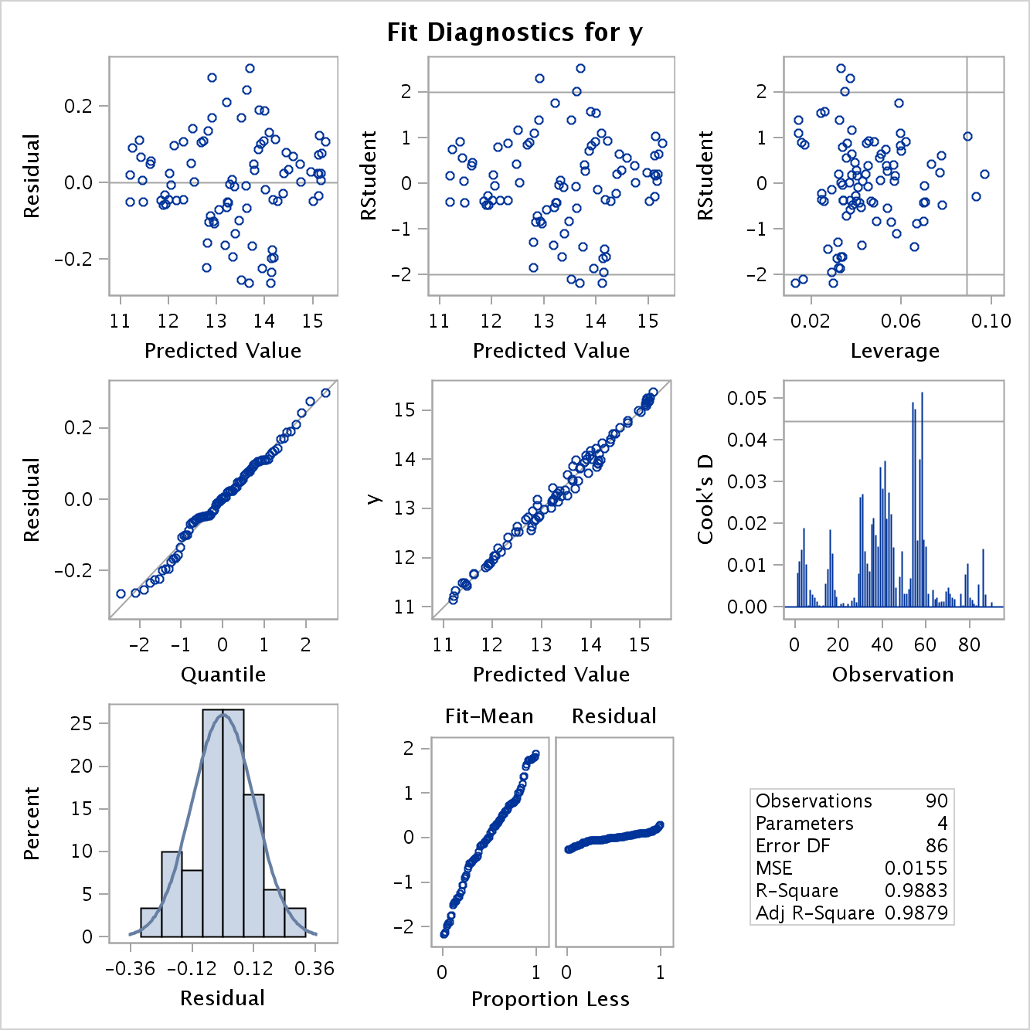 Residuals need to be independent of the independent variables. This assumption is called the Exogeneity of the Explanatory Variables (Ajmani). From the visual graphic to the right, one can see that there is no discernible pattern in the data points. This graphic satisfies the assumption that the error term is independent of the descriptor variables.

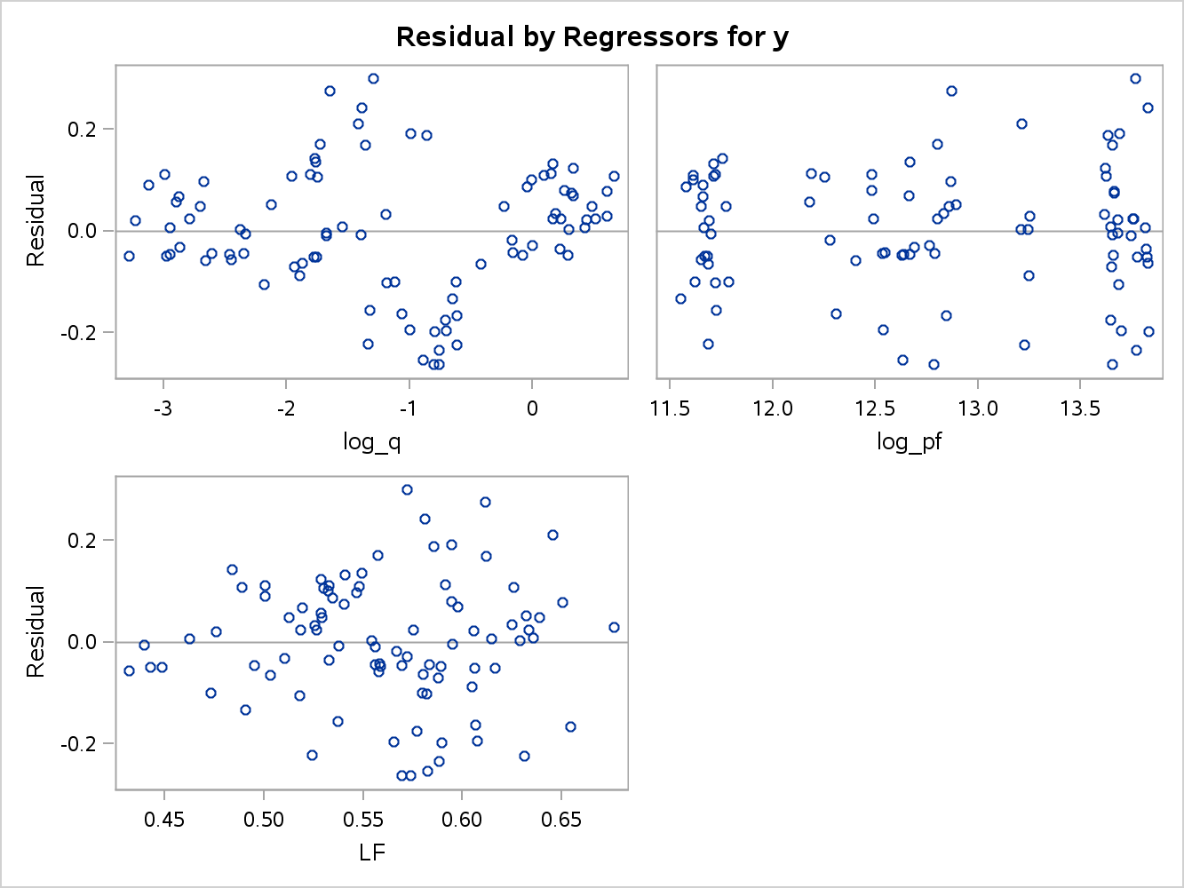 The assumption of random errors requires that the residuals are random, uncorrelated with one another, and have constant variance (Ajmani). Log_Q and Log_PF both look fine in regard to satisfying the Random Errors assumption. Variable LF and Y have cone appearance dispersions as load factor/total cost increase. Notice how the arrows widen as load factor increases. This behavior is symptomatic of heteroscedasticity which needs further investigation. In my opinion, if the heteroscedasticity cannot be resolved, dropping LF from the model would be a viable option seeing that it does not have a major contribution to the response variable.

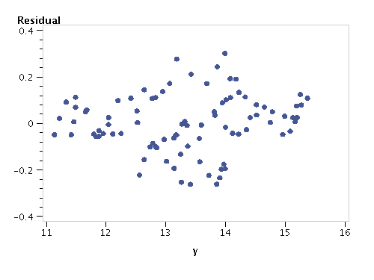

 Normal distribution is the last assumption for OLS, and stipulates that the errors have a normal distribution. Analyzing the Q-Q plot in SAS visually inspects to verify the assumption that the residuals follow a normal distribution. The normality errors fall along a 45 degree line which proves the assumption that the errors or residuals follow a normal distribution. It should be noted that fitting the regression model over the scatter plot is not relevant in multiple regression because more than one variable is used in the model, and the scatter plot with multiple variables does not validate linearity.

The plots demonstrate that there are not any major outliers. There are a few data points to note that are over .4. But given that this is nowhere near one standard deviation, it can be assumed that it is not an extreme outlier. In addition, one could assess the individual points to ascertain whether the points are valid outliers or noise. 

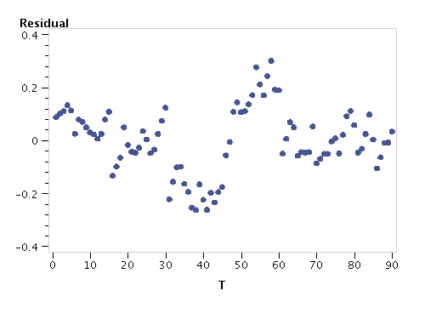 Management has requested a time series plot of the residuals. It should be noted that time (T) as a variable was excluded from the initial EDA. From my analysis, one can discern four clusters. While I do not have the skill set to discern the pattern, I would follow up with management in regard to this finding.

The model y= 9.517 + (LF*-1.628) + (.883*Log_Q ) + (.454 * Log_PF) has validated four of the five assumptions required to utilize OLS. The minor violation is with variable LF, and it suffers from heteroscedasticity, but it should not impinge on the overall model efficacy.

**Future Work**

Further recommendations on how this study can be improved upon are the following:

* Include updated binary variables that take into account whether or not the airline is a hub-and-spoke operation verses direct flight company.
* Delineate the data into groups based on ordinal rankings of airline profitability.
* Further analyze the micro-trends found in the scatter plots and residual plots.

Through this initial EDA, coupled with the future work recommendations, total cost can be reduced by focusing on maximizing value on specific variable outputs.

**References**

Borenstein, Severin. Phone interview. 16 Dec. 2011.

Ajmani, Vivek B.. *Applied Econometrics Using the SAS System*. Hoboken, NJ: Wiley, 2008. Print.

Borenstein, Severin. *Why Airlines Keep Going Bankrupt*. Washington DC: Interview - NPR, 2011. Print.

Chatterjee, Samprit, and Ali S. Hadi. *Regression Analysis by Example*. Fifth ed. Hoboken, New Jersey: Wiley, 2012. Print.

Cody, Ronald P.. *SAS Statistics by Example*. Cary, N.C.: SAS Pub., 2011. Print.

Greene, William H.. *Econometric Analysis*. 7th ed. Upper Saddle River, N.J.: Prentice Hall, 2012. Print.

Kenney, Caitlin. "Why Airlines Keep Going Bankrupt : Planet Money : NPR." *NPR : National Public Radio : News & Analysis, World, US, Music & Arts : NPR*. N.p., n.d. Web. 8 Jan. 2013. <http://www.npr.org/blogs/money/2011/12/16/143765367/why-airlines-keep-going-bankrupt>.

"Multicollinearity." *Statistics Solutions*. N.p., n.d. Web. 12 Jan. 2013. <http://www.statisticssolutions.com/resources/dissertation-resources/data-entry-and-management/multicollinearity>.

Najda, Charles. "Low-Cost Carriers and Low Fares: Competition and Concentration in the U.S. Airline Industry." *Stanford University Theses* 1 (2003): 9. *Department of Economics Stanford University*. Web. 8 Jan. 2013.

Ratner, Bruce. *Statistical and Machine-Learning Data Mining* . 2nd ed. Boca Raton, FL: CRC Press, 2012. Print.